How to retrieve or reset Public Portal login information (Parents)

When public portal login information is forgotten, such as username or password, you can retrieve your forgotten username or reset your forgotten password. To reset your password, you need to know your username and email associated with your public portal account. If you want to retrieve your username, you need to know your email associated with your public portal account.

Resetting your password

- From the main Public Portal login page, click on Forgot Username or Password?

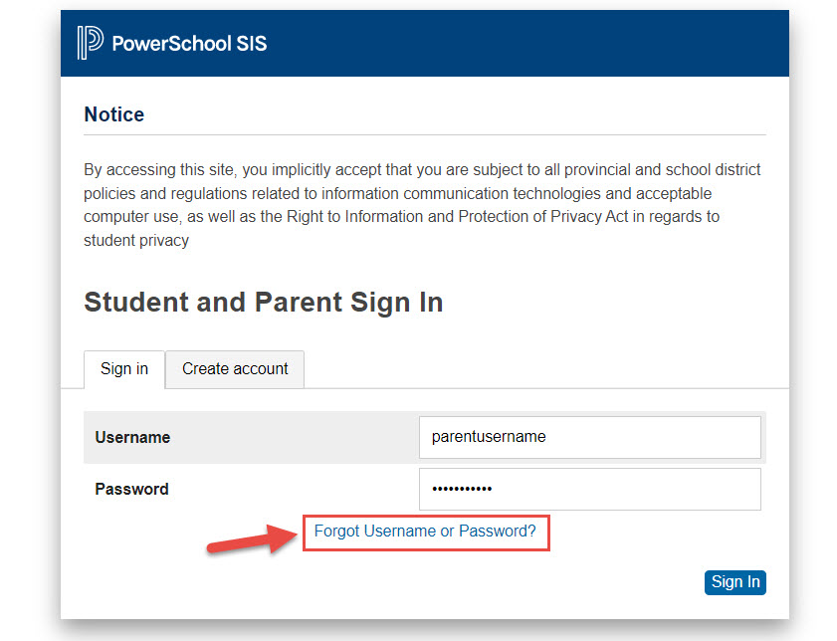

- To reset your password, enter your username and email that are associated with your public portal account, and click on enter.
If you do not receive an email within the next 5 minutes, it indicates that the information entered does not match. You will need to contact the school for support.
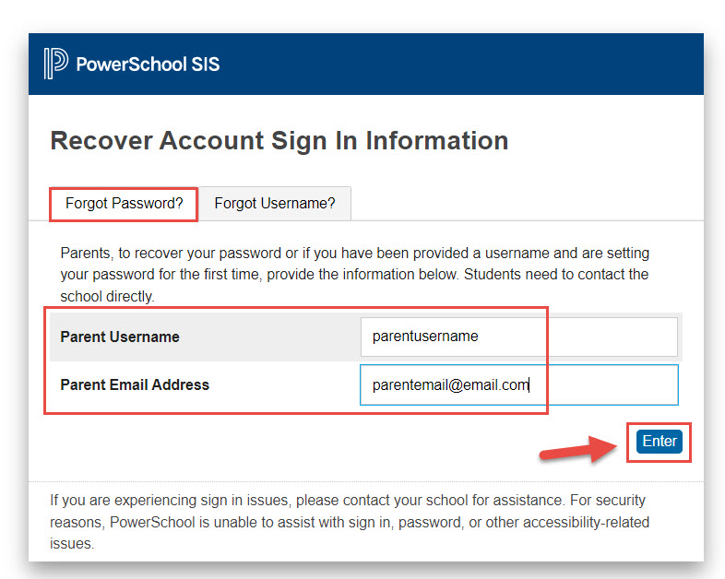

- After you select enter you will be greeted with the following message.
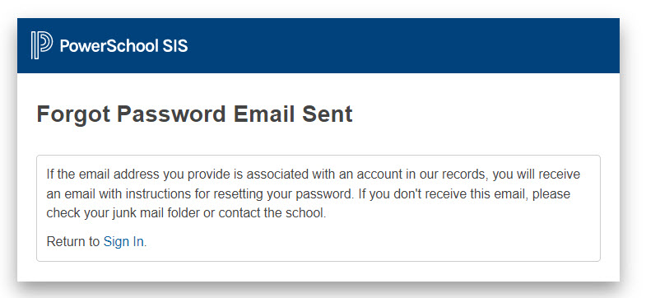
- If the information you entered is accurate, you will receive the following email, click on the link and it will take you to a page that will ask you to enter a new password.
PS. The link is valid for 24 hours.
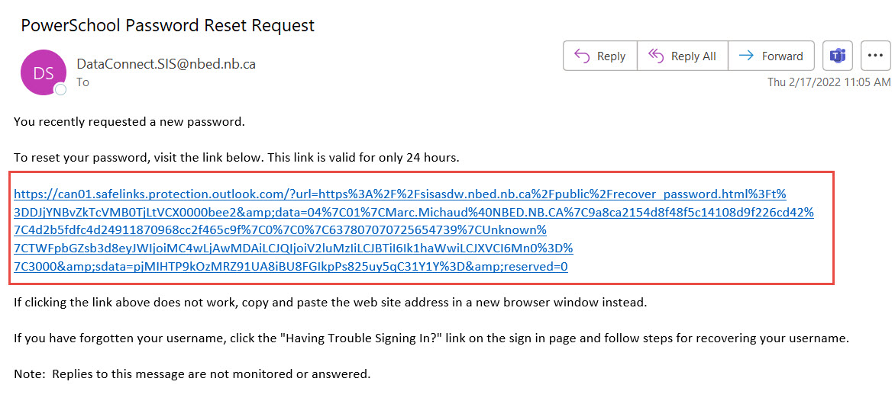

- Enter your username, then select a new password. Your password will need to meet the security requirements listed. Once your password is updated, select enter, and you will be signed in automatically.
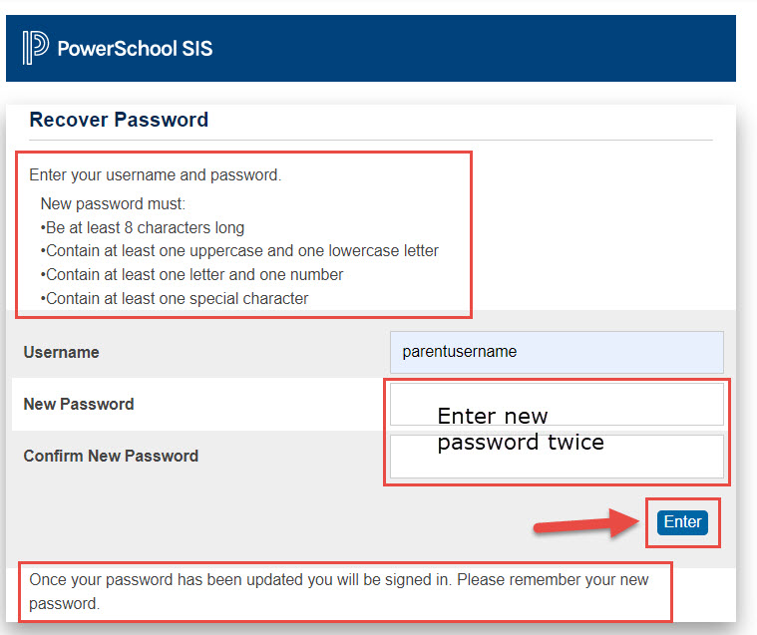
Retrieving a forgotten username
- From the main Public Portal login page, click on Forgot Username or Password?

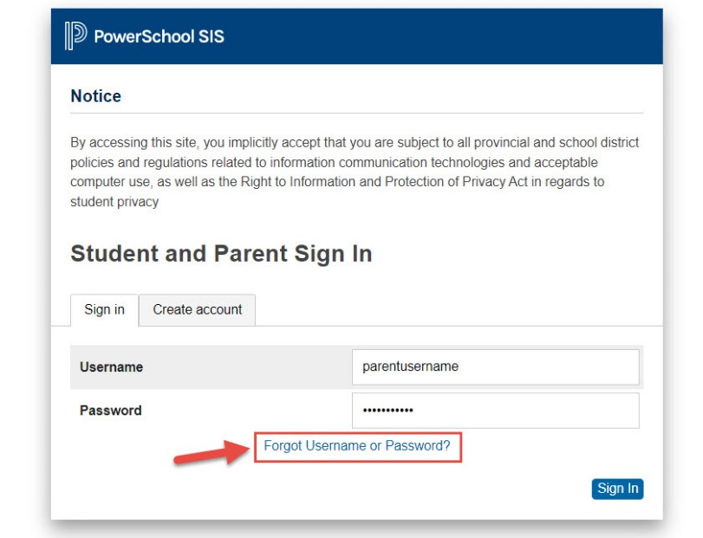

- To retrieve your username, select the “Forgot Username?” tab and enter the email that is associated with your public portal account, then click on enter.
If you do not receive an email within the next 5 minutes, it indicates that the information entered does not match. You will need to contact the school for support.

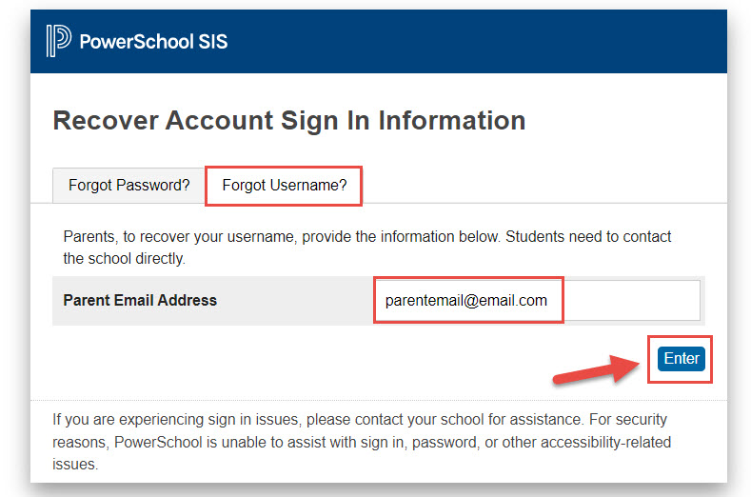
- After you select enter you will be greeted with the following message.
PS. Whether you select forgot password or forgot username, you will be greeted with the same message.

- If the information you entered is accurate, you will receive the following email, containing your forgotten username.
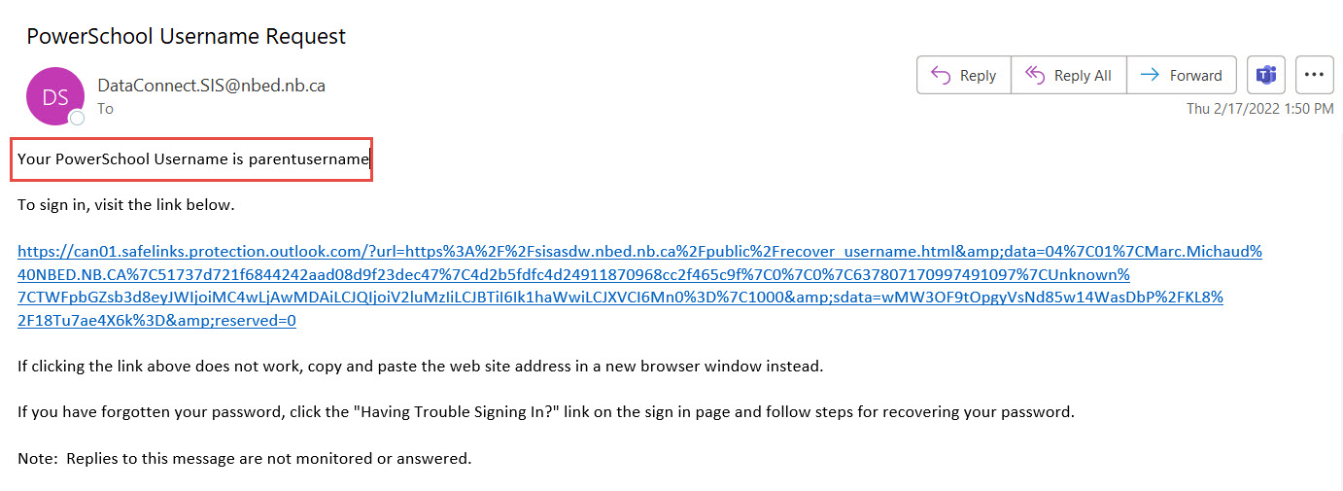
Process Name: | How to retrieve or reset Public Portal login information (Parents)
Last Updated: | 2/17/2022 2:13:00 PM
Initial Author: | Marc Michaud
Last Updated by:
Time period(s) most often used: | All Year

